Contents

Pseudo Code 1

Test Data ..........................................................................................................................8

User Guide …………………………………………………………………………………………………………………10

The Menu. 10

Option 1: Add an entry. 10

Option 2: Display names and numbers you have entered. 11

Option 3: Display all 20 records. 11

Option 4: Delete an entry. 11

Option 5: Delete all records. 12

Option 6: Search for a phone number. 12

Quitting the program. 13

Frequently Asked Questions. 14

## Pseudo Code

**Level 1**

A phonebook application with a maximum of 20 entries. Allows the user to;

Add a new name a number to a given record number

Display only the records where a name and number has been entered.

Display the contents of all twenty numbers, regardless of content.

Delete a name and number from a given record number

Remove all names and numbers from all records, resetting all records to their default state.

Search for the phone number of a name specified by the user.

**Level 2**

Initialise all 20 records with “xx” for first name “yy” for surname and “00” for phone number

Display menu options for user.

Enter into switch statement and run relevant case.

Option 1 - User enters box number.

Program checks if the user has already entered a name and number into this box and ask for confirmation to overwrite. If yes program continues, if not repeats question.

User enters name.

User enters phone number

Confirmation displayed on screen

Repeat or back to menu. Method to check ‘y’ or ‘n’ pressed.

Option 2 - Display on screen names and numbers entered by user.

Option 3 – Display all records regardless of user input.

Option 4 - User chooses box number to delete

Confirmation displayed on screen.

Repeat or back to menu. Method to check ‘y’ or ‘n’ pressed

Option 5 - Program asks if the user is sure they want all records reset.

User presses ‘y’ to confirm or ‘n’ to leave records as they are.

Method to check ‘y’ or ‘n’ pressed.

Confirmation of action displayed on screen.

Option 6 –

User selects to search by first name, surname or whole name.

User enters name to search

All records matching that name are displayed for user on screen.

Repeat or back to menu.

Option 7 - Quit the program.

Methods used;

Method to enter “xx” as first name, “yy” as surname and “00” as phone number.

Method to add an entry

Asks for name then number.

Checks input to validate a number was entered.

Displays confirmation of entry added.

Method to check number.

Removes any blank spaces from the input (i.e. 1 2 3 becomes 123)

Converts string to number to check if the input was a number.

If a number passes it back to the main, if not asks for a number until a number is entered.

Method to check box number.

Converts input to integer

Checks if the number is from 0 to 19.

Keeps asking for 0 to 19 until 0 to 19 is entered at which point this is passed back to the main program.

Method to check ‘y’ or ‘n’ pressed

Check key press for ‘y’ or ‘n’

If not ask until ‘y’ or ‘n’ pressed

**Level 3**

**Start**

Sets up variables

Passes entries array to populate method

Print welcome to phonebook program.

**Start of Do While Loop**

Displays options and button to press

1 to add entry

2 to show entries user has added

3 to show all 20 entries

4 to delete one entry

5 to delete all entries

6 to search for a phone number.

‘q’ to quit the program

Switch user choice

**1 adds entry**

Asks user for box number

Read box number from keyboard

Checks number is an integer using NumCheck method

Checks the number is from 0 to 19 to fit array parameters.

Checks if box has already been populated by the user

Asks for confirmation for overwrite if user has already entered data.

Once satisfied goes to AddEntry method to update entries array.

Should user not wish to overwrite the program will skip AddEntry method.

Ask user if they want to add another entry.

Pass to YesNo method

If yes, goes back to start of case.

If not, returns to main menu.

**2 Display all populated fields**

For loop (From 0 until counter is less than 20)

Checks if first name is not “xx”, surname is not “yy” and phone number is not “00”.

If not then name and number is printed on screen.

If they are nothing is printed on screen.

Returns to main menu.

**3 Display all 20 records.**

For loop (From 0 until counter is less than 20)

Print first name from records 0 to 19 in the names array.

Print surname from records 0 to 19 in the names array.

Print phone number from records 0 to 19 in the phone numbers array.

Returns to main menu

**4 Delete an entry**

Ask user for box number to delete.

Passes to BoxCheck method to check if valid box number

Stores “xx” in first name, “yy” in surname and “00” in phone number.

Prints confirmation for user.

Asks user if they want to delete another entry.

Pass to YesNo method.

If yes goes back to start of the case.

If not, returns to main menu.

**5 Delete all records**

Asks user if they are certain that they want to delete all records.

Decision taken from read key statement

Pass to YesNo method

If ‘y’ runs the Populate method

If ‘n’ then returns to main menu.

**6 Search for a phone number**

Asks user if they want to search by first name, surname or whole name.

Asks user to enter a name. (Either first name, surname or first name then surname).

For loop (From 0 until counter is less than 20)

Checks if entry equals name entered

If it is prints the name and number on screen

If not nothing is printed.

Ask if user wants to search another name.

Pass to YesNo Method.

If yes goes to start of case.

If not returns to main menu.

**q Quit the program**

User asked if they are sure they want to quit.

User decision taken by read key statement.

Pass to YesNo method.

If ‘y’ program displays farewell message and hangs for 2.5 seconds.

If ‘n’ program returns to main menu.

**End of Do While loop. Cuts when q selected.**

**End of main program.**

**Methods**

**Populate**

For loop

Stores “xx” as first name and “yy” as surname.

Store “00” as phone number

**AddEntry**

Ask for first name

Reads first name from keyboard

Ask for surname

Reads surname from keyboard.

Ask for number

Stores number from keyboard as string

Removes any spaces input by user

Passes to NumCheck method

Stores names in names array and number in phone numbers array selected by user

**NumCheck**

Set up variables

Remove spaces from string

Convert to int and use bool to test if number or not

If is a number pass back to main program.

If not a number ask for new input

Loop until number entered.

**BoxCheck**

Check number entered is from 0 – 19

If yes pass back to main program

If not ask user for another number

Check number entered using NumCheck

Loop until 0 – 19 entered.

**YesNo**

Check if key press was ‘y’ or ‘n’

If it is pass back to main program

If not ask for another key press

Loop until ‘y’ or ‘n’ entered

# User Guide

### The Menu.

Before anything happens you will be greeted by the main menu. As seen in figure 1.

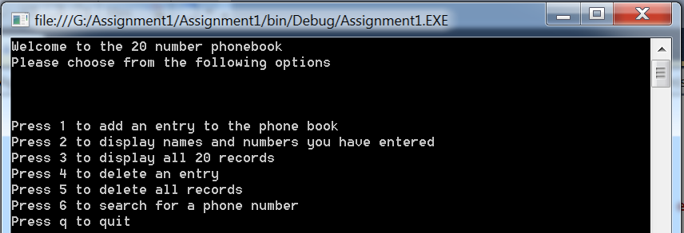

Figure 1

All you need to do is press the corresponding key to the action you wish to take.

### Option 1: Add an entry.

1. Select a box number from 0 to 19. This will indicate which field you wish to put the name and number in. If the box already contains a name and number you will be asked to confirm that you want to overwrite this.
2. Enter the first name and press enter. Repeat this action for the surname and the phone number.
3. You will see a confirmation of the data you have entered into the box. See figure 2.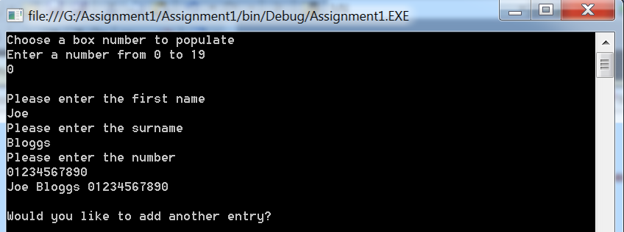

Figure 2

1. You will then be asked if you want to add another entry. Press ‘y’ if you do want to or ‘n’ to return to the main menu.

### Option 2: Display names and numbers you have entered.

This allows you to see all the names and numbers you have entered thus far. You will be instructed to press enter to return to the main menu. See figure 3.

### 

Figure 3

### Option 3: Display all 20 records.

By default all first names are entered as xx. All the surnames are entered as yy and all phone numbers are entered as 00. By choosing option 3 you will see all 20 boxes, including those that currently contain these default values. You will be instructed to press enter to return to the main menu. See figure 4.

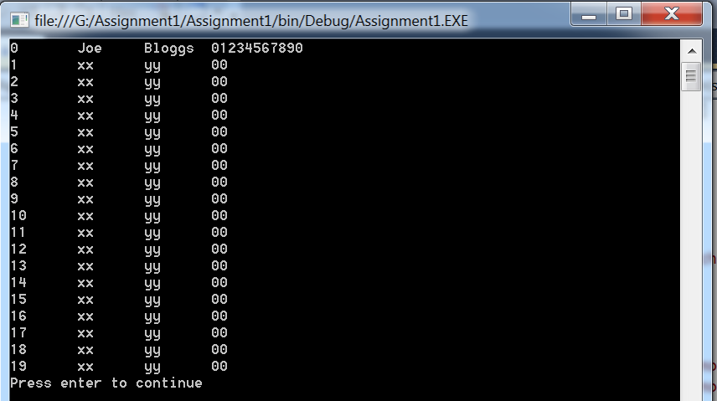

Figure 4

### Option 4: Delete an entry.

1. Select the box number you wish to reset to xx yy 00. Make sure you know the number beforehand by using option 2 or 3.
2. You will then see a confirmation message stating that the box has been reset to xx yy 00. See figure 5.

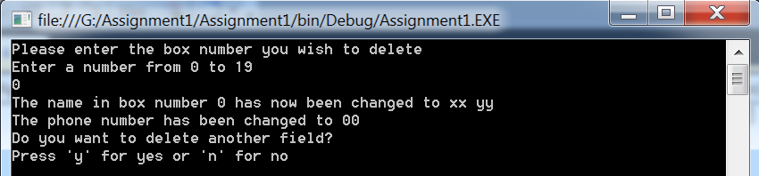

Figure 5

1. If you select yes you will be asked for another box number to reset.
2. If you select no you will return to the main menu.

### Option 5: Delete all records.

This will ask for confirmation that you really do want to reset all the records. If you press y for yes all fields will now be xx yy 00. A confirmation will be displayed. See figure 6.

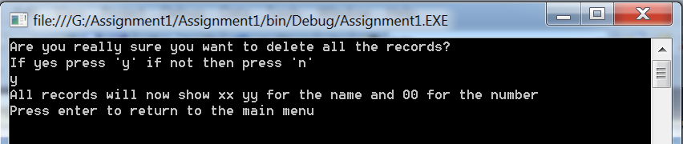

Figure 6

If you press n for no you will be taken back to the main menu and all the records will not be affected.

### Option 6: Search for a phone number.

1. Press 1 to search by first name, 2 by surname or 3 by whole name.
2. If searching by first name enter the name then press enter. All fields that match that first name will then be displayed. See figure 7.

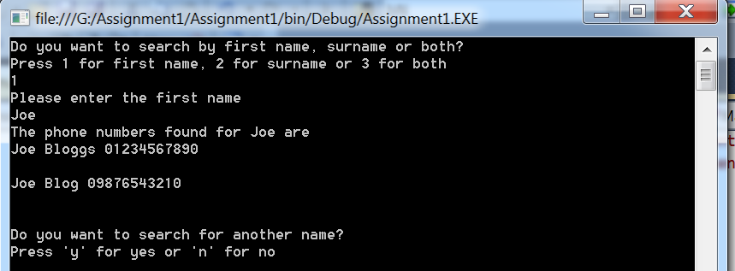

Figure 7

1. To search by surname you do the same by selecting option 2 and entering the surname you want to search by. See figure 8.

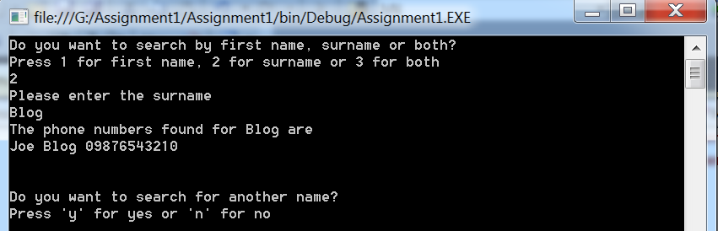

Figure 8

Note here how only Joe Blog was displayed, rather than both Joe Bloggs and Joe Blog.

1. Searching by the whole name will ask you to enter the first name then the surname. Only fields that match both the first name and surname will be displayed. See figure 9.

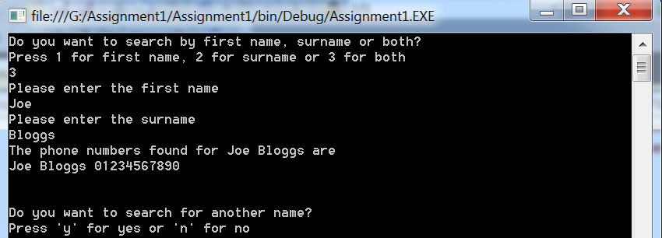

Figure 9

### Quitting the program.

To quit the program simply press q at the main menu. You will be asked for confirmation and either close the program if you press y, or it will return to the main menu if you press n. See figure 10.

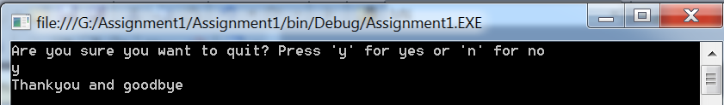

Figure 10

### Frequently Asked Questions.

1. Why, when I enter 20 is it telling me this is an invalid box number?

The box numbers run from 0 to 19 so there are 20 boxes but 19 is the last and 0 will be the first.

1. Why does the program tell me I have given an invalid selection when I press q, y or n?

Please make sure you are not using capitals. You may have the caps lock on and this will make the program think you are pressing Q rather than q. All options are in lower case where you need to make a selection by letter.

1. I’m pressing numbers on the numpad but it’s telling me this is an invalid selection. Why is this happening?

You may not have numlock on. Try pressing the numlock button, this should resolve the issue.

1. Why, when I search for a name does it not show the name I entered even though I know it’s there?

The search is case sensitive so the program will think that joe is different to Joe.

### References

C# code, pseudo code and test methods studied and used from;

Bell.D. & Parr.M. (2009). *C# For Students Revised Edition.* Pearson Education Limited.

Arrays.txt, TestRecord.doc, Software Testing.ppt, Lecture ppts.ppt (from vle.anglia.ac.uk)

Personal lecture notes gained through attending lectures held by M.Roots.